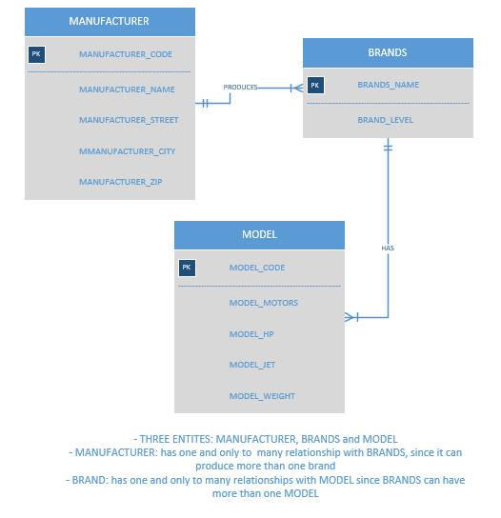

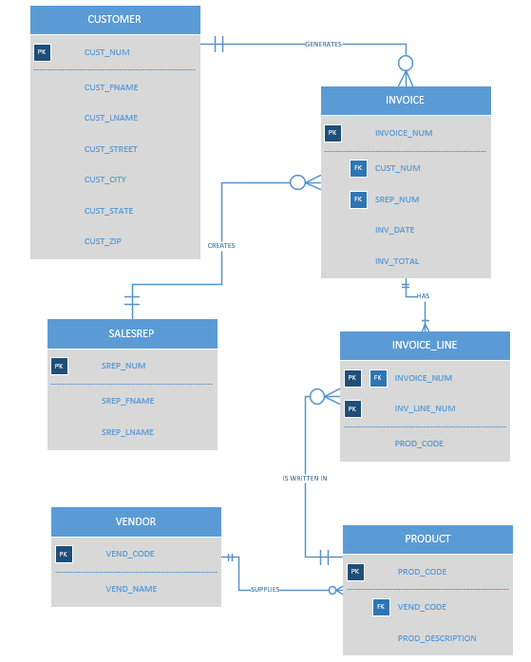

|  |  |  |  |
| --- | --- | --- | --- |
| **5. A**  **ENTITY** | **RELATIONSHIP** | **CONNECTIVITY** | **ENITITY** |
| **INSTRUCTOR** | **TEACHES** | **1:M** | **CLASS** |
| **COURSE** | **GENERATES** | **1:M** | **CLASS** |
| **CLASS** | **IS LISTED IN** | **1:M** | **ENROLL** |
| **TRAINEE** | **IS WRITTEN** | **1:M** | **ENROLL** |

5-A) Entities and relationship are listed above.

5-B).

**Each class is taught by one instructor** One and only instructor teaches since business rules states that each instructor may teach up to two classes. Relationship one to many classes.

Each Class must be linked to course, one and only course can generate one to many classes.

Each instructor may teach up to two classes or may be assigned to do research only

Each trainee may take up to two classes per year, not all are likely to be enrolled in classes.